UN Women

Meet the Chairs

Co President - Theja Nadeeja Amarasiri

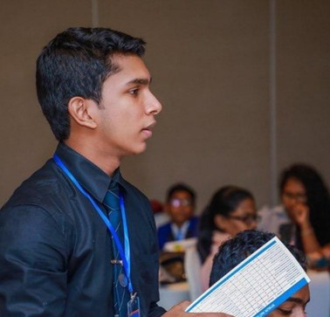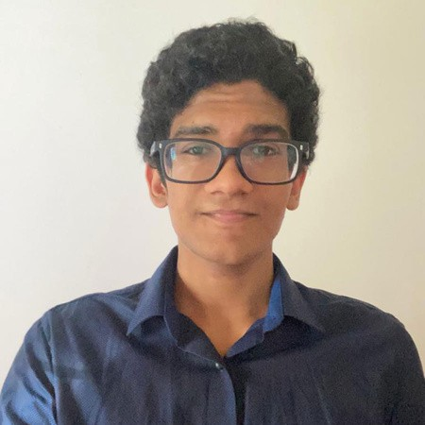Co President - Senuth Uluwatta

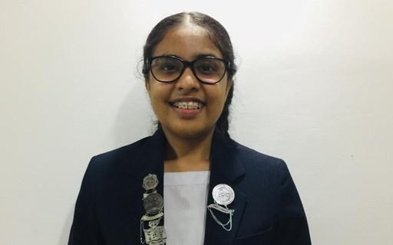Vice President - Sachinthani Katakumbura